June 2025 Certified Leadership Program Attendee Feedback

CHAPCA’s June 2025 Certified Leadership Program brought together hospice leaders across California for three days of intensive training, networking, and leadership development. Here's what attendees had to say.

# Program Impact Direct from Attendees:

**Expectations Met:**

* 71% said it Exceeded Expectations
* 29% said it Met Expectations
* 0% said it did not meet expectations

**Content Relevance:**

* 76% found it Extremely Relevant
* 24% found it Very Relevant
* 0% found it irrelevant

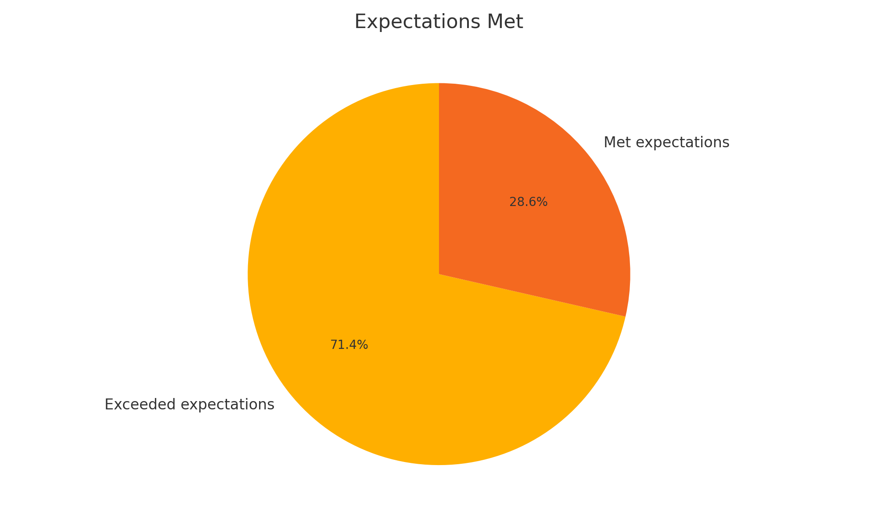

# What Attendees Are Saying:

*⭐️ “Exceeded my expectations—timely topics and real-world insight I can apply immediately.”*

*⭐️ “Every session brought clarity and tools I can bring back to my team.”*

*⭐️ “The speakers were outstanding—engaging, informed, and practical.”*

*⭐️ “This was one of the most relevant leadership trainings I’ve attended in years.”*

*⭐️ “As a new hospice administrator, this gave me a framework and confidence boost I didn’t know I needed.”*

**We look forward to seeing you at our next CHAPCA Certified Leadership Program on December 2,3,4, 2025!**